CDH Installation

----> Done all pre-requisites

----> Created Local repo : - # vi /etc/yum.repos.d/cloudera-manager.repo

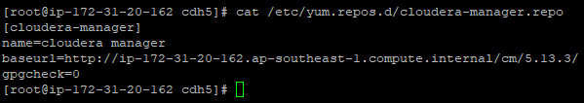

----> Copied this repo to all nodes

----> Downloaded repo tar file for Cloudera manager cm version 5.13.

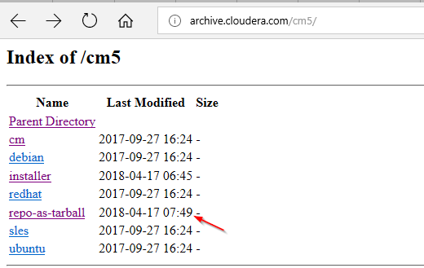

---> untarred it and placed in /var/www/html

----> copied the http url and made it baseurl in cloudera-manager.repo

----> #yum clean all

----> #yum makecache -----> did in all the nodes

Installing MySQL server and connector and creating database:

---> installed MySQL server and connector : # yum -y install MySQL-server MySQL-connector-java

---> created new user named "mohan" and password "password"

---> granted all privileges to the user mohan and connected with cloudera manager.

----> # /usr/share/cmf/schema/scm_prepare_database.sh mysql -h ip-172-31-20-162.ap-southeast-1.compute.internal -umohan -ppassword --scm-host ip-172-31-20-162.ap-southeast-1.compute.internal scm scm scm

---> installed cloudera-manager-server, agent, deamons in the cloudera-manager server

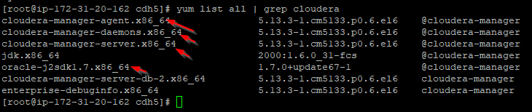

---> Installed clloudera-manager-agent, deomons in remaining nodes.

---> started cloudera manager server and agent

# service cloudera-scm-server start

# service cloudera-scm-agent start

----> before that pasted the cloudera-manager hostname in /etc/cloudera-scm-agent/config.ini

# vi /etc/cloudera-scm-agent/config.ini

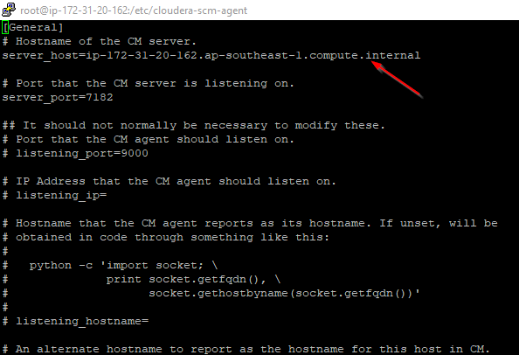

---🡪 Opened the cloudera manager UI

<http://13.229.223.33:7180>

--🡪 Downloaded the cdh 5.13.3.2 parcel and pasted in /var/www/html/cm/parcels/cdh

Using Cloudera manager UI, installed the selected services(custom services)

